When working in groups there are common risks or issues that surface.  You will create a risk register that outlines 5 common problems, mitigation and contingency to manage them for your work in this class with your teams.  This document will serve as your team contract and is what your instructor will refer back to if there are any reported problems.  Take the time and effort to make this a working document for your group management.

**RISK ANALYSIS SAMPLE TEMPLATE**

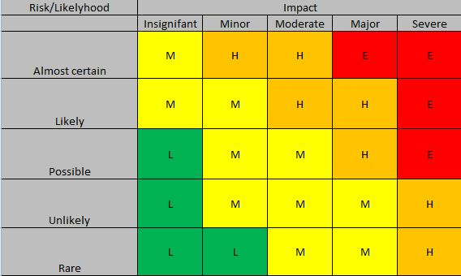

Insignifant – very little impact to timeline and budget. Project remains on track

Minor – more than a 5 day increase to time line and $30,000 addition to budget

Moderate – more than a 14 day increase to time line and $50,000 addition to budget

Major – more than a 21 day increase in schedule, $75,000 addition to budget and 20% reduction in scope, project failure is possible

Severe – Project failure

PLEASE NOTE YOU MUST MODIFY THIS LEGEND TO SUIT YOUR PROJECT.

| **Description of Risk or Hazard** | **Risk or Likelihood** | **Impact** | **Rating**  **(L, M, H, E)** | **Mitigation Strategies (preemptive measures)** | **Adjusted Rating after Mitigation (L, M, H, E)** | **Contingency Plan (List of steps to deal with an occurrence)** |
| --- | --- | --- | --- | --- | --- | --- |
| *Paper cuts to hands* | *rare* | *insignificant* | *L* | *Develop warning signs of potential sharp papers Inform staff; where first aid kit is located; stock a variety of bandages* | *No Change* | *Step 1: Wash cut area with water and soap*  *Step 2: Assess the deepness of the cut*  *Step 3: Apply “band-aid” to protect damaged area* |
| *Data loss due to equipment failure* | *possible* | *major - severe* | *H - E* | *Promote data retention protocols and incorporate cloud storage; Data stored on network servers, regular back up of data, redundant hardware systems set up* | *M (reduced impact)* | *Access backup files; restore lost content to last backup point; assess data loss impact; communicate data loss to key stakeholders;* |
| *<Add more rows when needed>* |  |  |  |  |  |  |